# Trace FC Tutorial: Running Experiment

## Introduction

(Note that this will eventually be replaced with a jupyter notebook once I figure out how to nicely embed figures on windows).

This tutorial will cover the steps in **bold** here:

1. Handle animals
2. Set up hardware and arenas
3. **Set up software**
4. **Run experiment**
5. Organize/backup data

## Set up software

### USV RECORDING

First, open up AVISoft recorder for recording ultrasonic vocalizations (USVs) and go to the configuration dialog box:

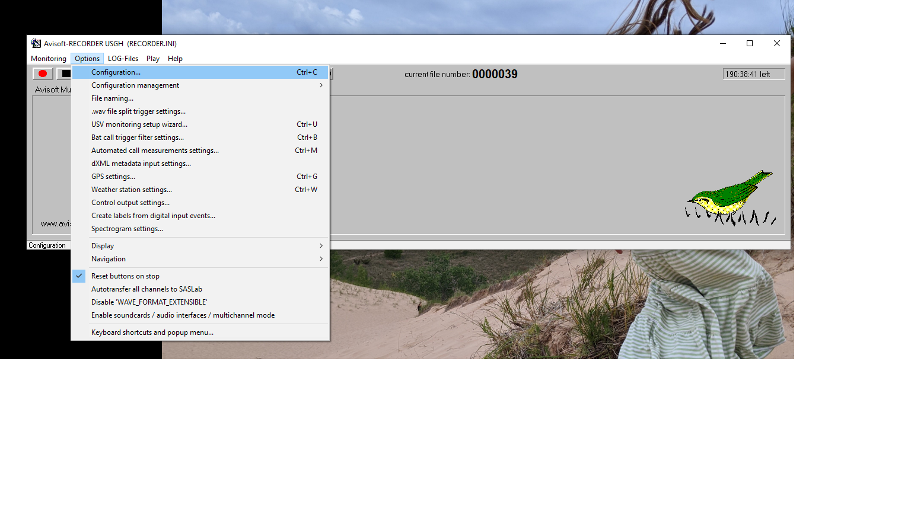

Second, name each channel to as below to match the channel each microphone is connected to by filling in the text in the red box below.

Then, make sure you are saving everything to the appropriately named folder for your experiment (typically Ratxxx in the Documents\Recordings folder) – see green box below.

Last, hit “Config File -> Save As” and save to the same folder as the base directory – see yellow below.

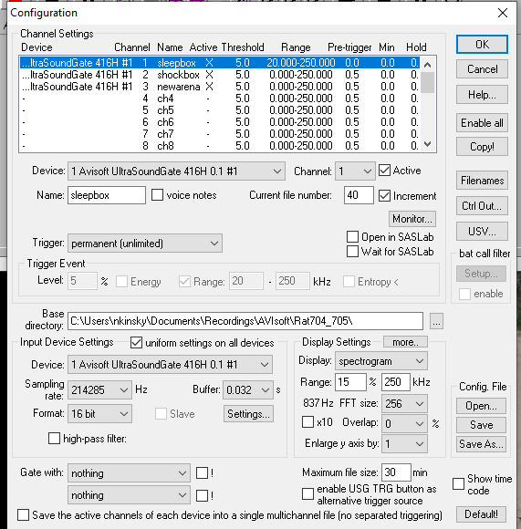

Third, uncheck all but the active microphone by toggling the “Active” box for each channel – see red box below.

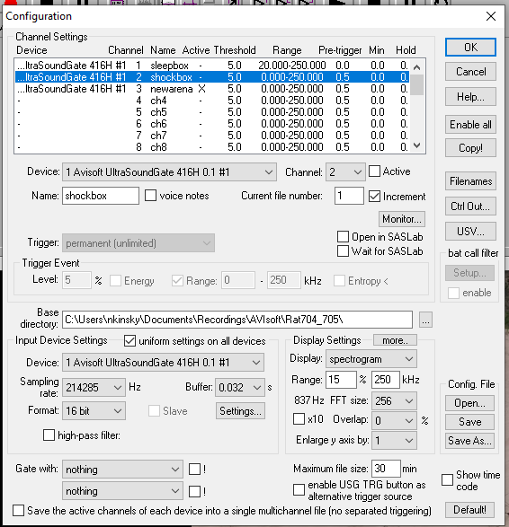

Finally, make sure that the microphone is working by hitting record and then going over to the microphone and snapping your fingers. (Note that it is a bit buggy and you might have to close an error box and hit record again to get things working). You should see a nice response across all frequencies. If it doesn’t look that strong, double check to make sure you have the correct microphone selected and that each microphone is connected to the correct port.

You are all set to record USVs!

### BEHAVIORAL RECORDING

First, open up Motive (type “motive” in start menu) AND Camera (type “Camera” in start menu). You should see something pop up like this below. Make sure that you have selected the correct camera for the recording by clicking “Enable” in red box below. The other cameras should show up as black.

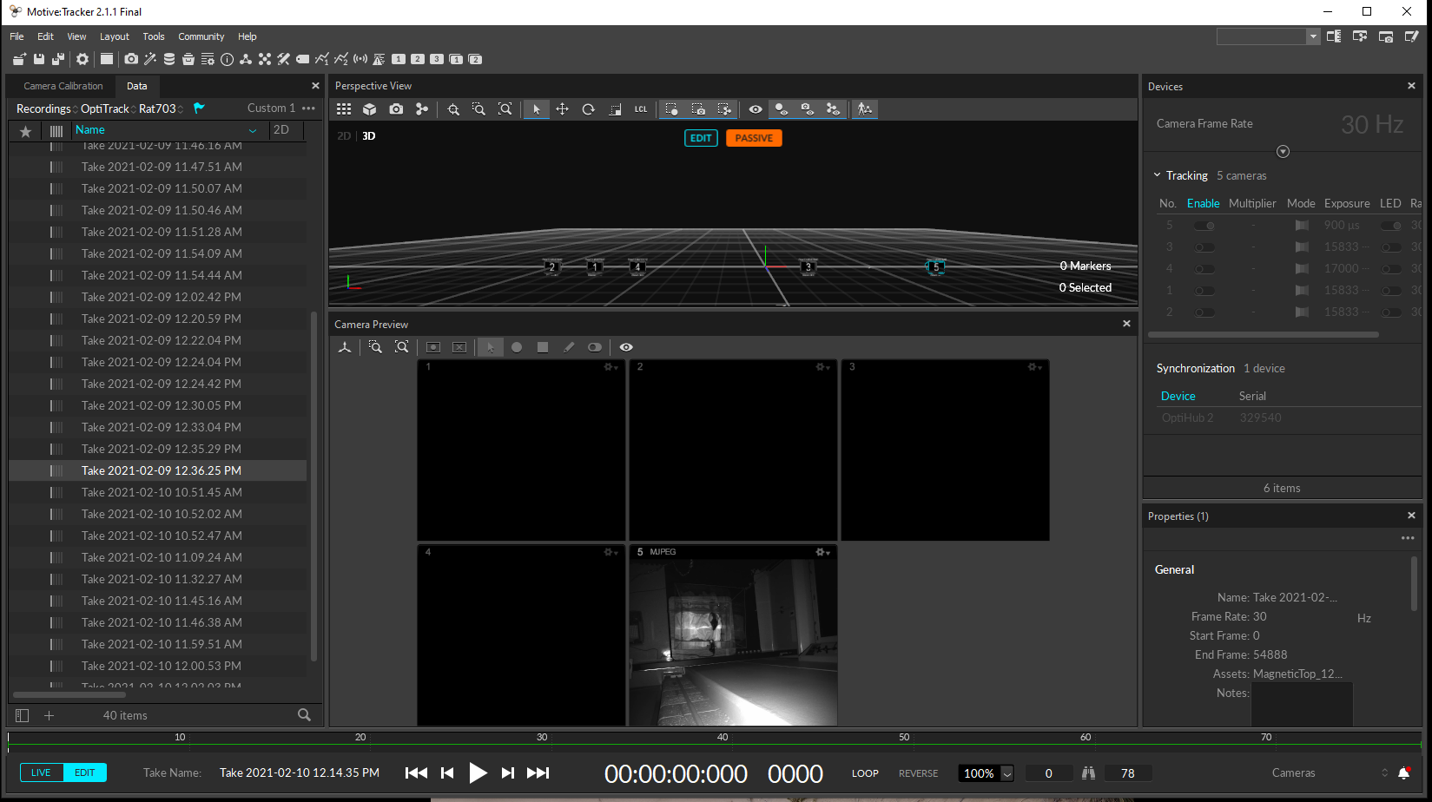

If this is your first recording for a given animal, make sure to designate where the files will go by selecting “Add session folder” from the file menu and creating a folder with the rat’s name (typically in the “Documents” folder):

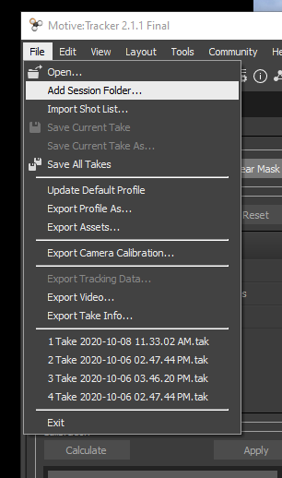

Double check recordings are working by hitting the red button at the bottom to start recording and making sure something shows up in the designated folder.

You may have to adjust exposure times for each camera and/or ensure that the “LED” slider is on in order to get good contrast/brightness.

#### IMPORTANT NOTE:

If you see any flickering or gray lines at the bottom of the camera, talk to Nat/Bapun – it will likely crash so make some adjustments before proceeding!

Finally, set up the webcam, which serves as a backup in case Motive crashes. All you need to do is CAREFULLY get up on the step ladder and adjust where the camera points so that it shows up looking at the correct arena for the session you are recording in the Camera application.

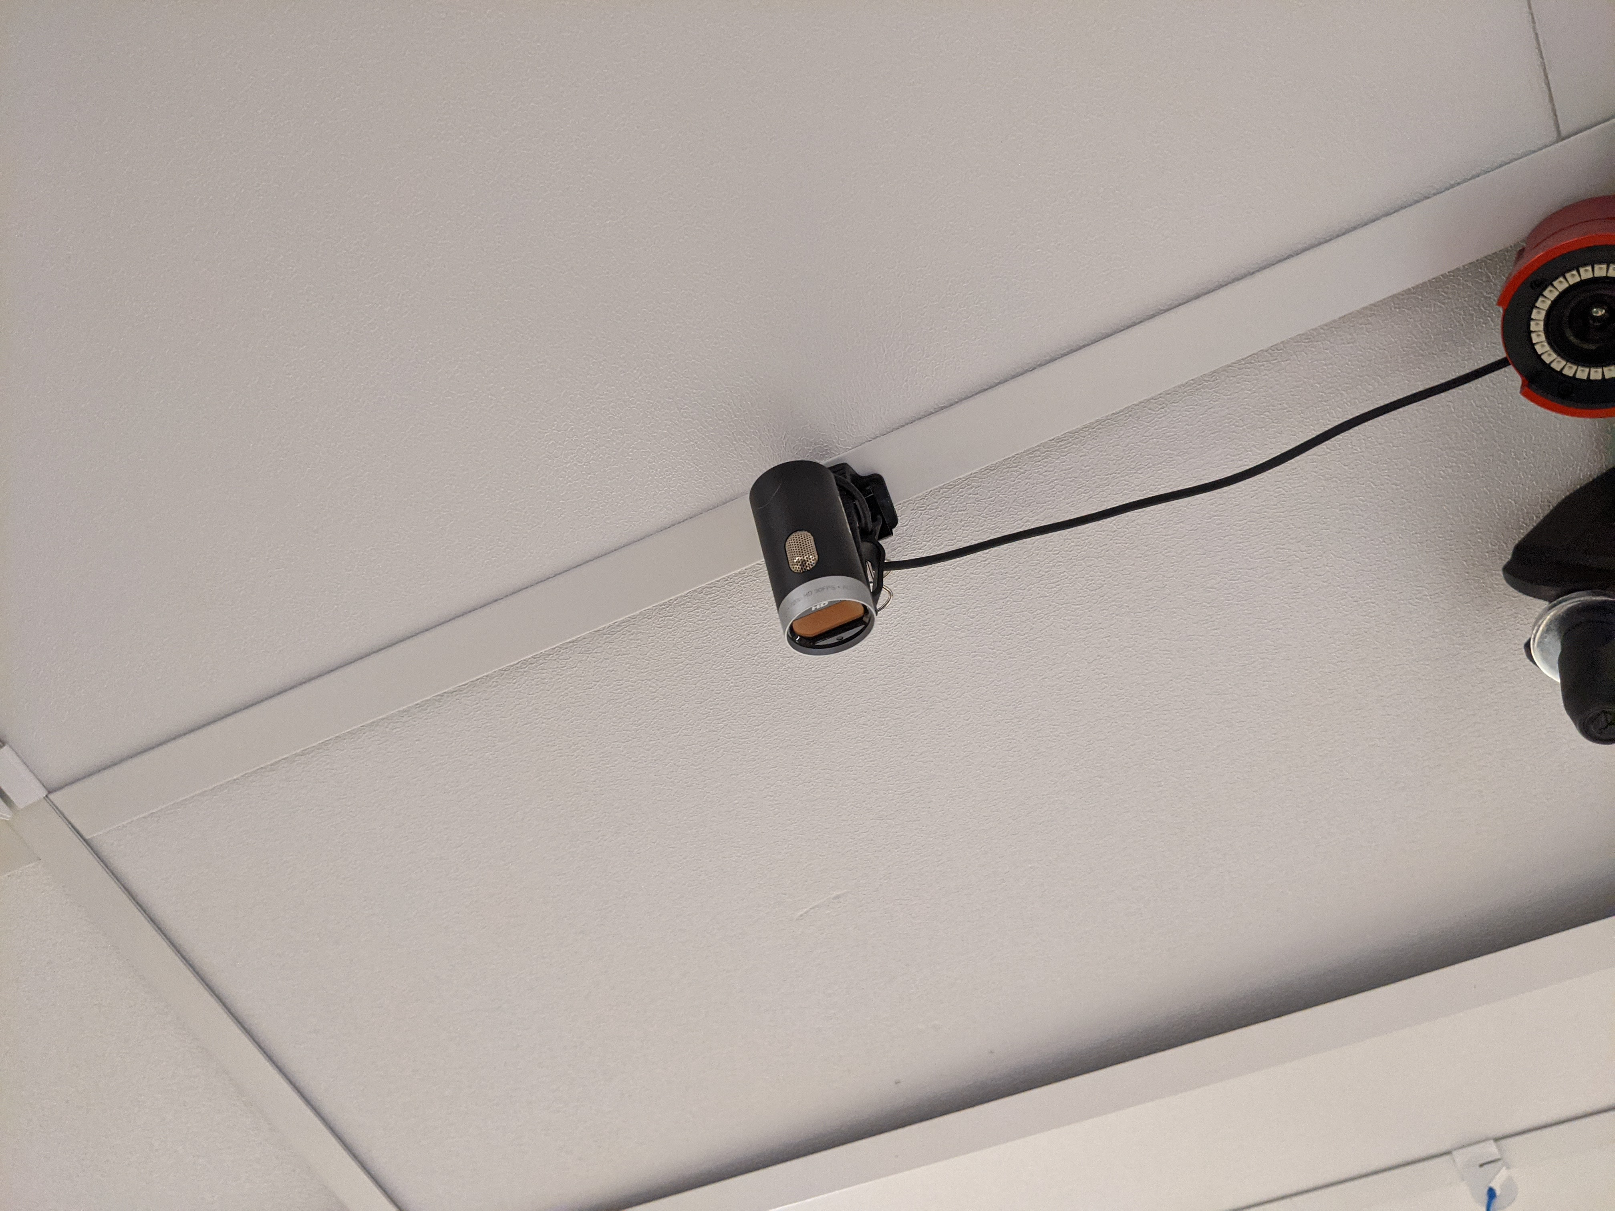

Again, test to make sure it is working by clicking RECORD and ensuring you see a new file show up in the location below.

IMPORTANT NOTE: This app will STOP RECORDING if you minimize it, so be sure to not do that!

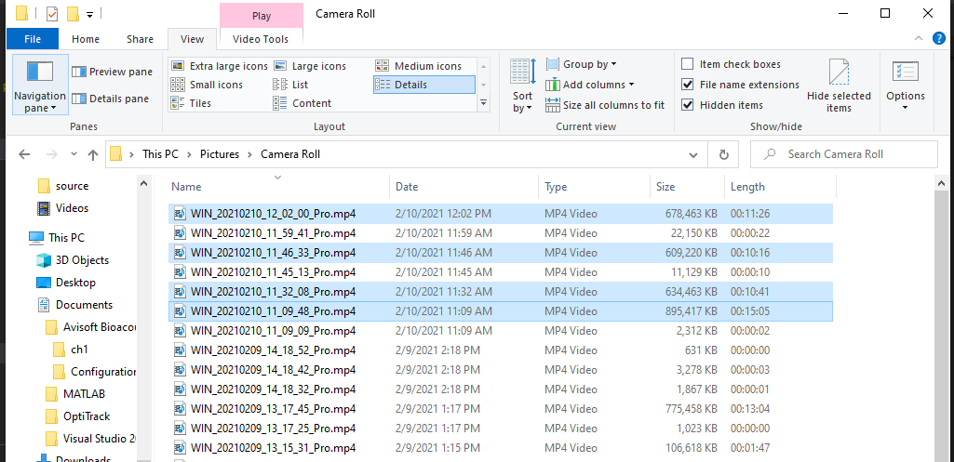

### PYTHON

First, open up an anaconda prompt (Type in “Anaconda” and select “Anaconda Powershell Prompt (Miniconda3)”.

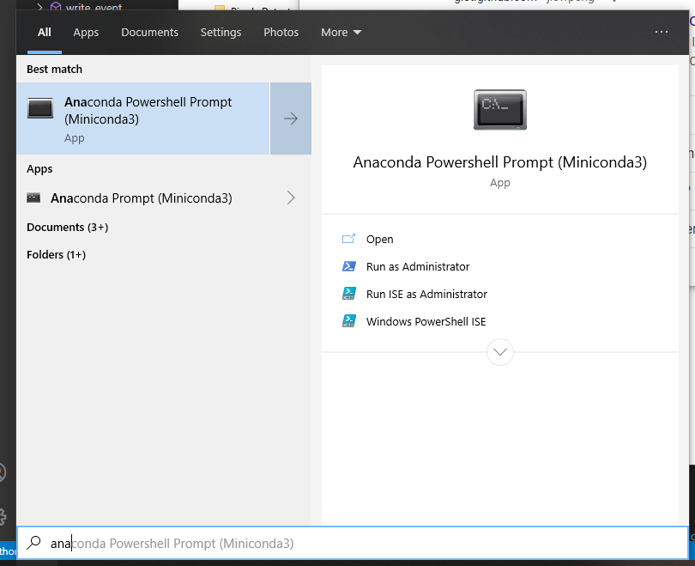

A terminal should pop up that looks like this. If it’s not in the same directory, navigate to it by typing “cd c:\location_of_python_code_here” (replace the last part with the path to where the python module “trace_conditioning.py” and “tones.py” are located if you’ve put them somewhere else.

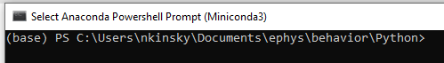

Type in “ipython” to start an interactive python terminal.

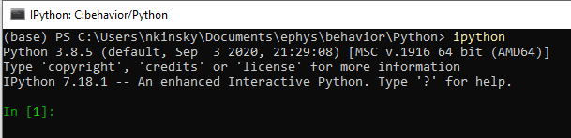

Finally, initialize the “trace” python class which you will use to run ALL parts of the experiment as follows:

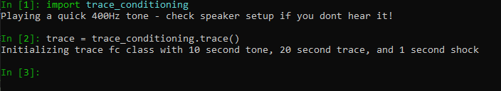

You should here a short tone over the speaker. If you don’t, check to make sure everything is properly connected to the computer, turned on, etc.

#### IMPORTANT NOTE:

ipython is smart and will auto-complete if you type in a few letters and then hit tab. For example, if I wanted to import “trace conditioning” I could hit tab after typing in the first few letters, then use the up/down key to navigate to “trace_conditioning” and hit enter to select (see below). It also has a history function where you can hit the up/down keys to access previous commands.

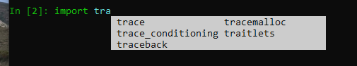

Ok, now you are ready to run your experiment!

## Running the experiment

### BRING ANIMAL INTO ROOM

After you are satisfied everything is set up properly, bring the animal into the room.

### START UP PYTHON CLASS

First, get the python class up and running as follows – it will set up everything to automatically synchronize via the attached Arduino.



You’ll need to enter in the correct name for the recording session as a string (i.e. in single or double quotes). In the above example I’ve entered “pre” because this will be the first recording of any day.

#### Session options

The following are valid options for a recording session: ‘pre’, ‘post’, ‘habituation’, ‘training’, ‘tone_recall’, ‘ctx_recall’ and happen in the following order:

**Day 0:** ‘pre’ (15 min in sleep box), ‘habituation’ (20 minutes in shock box), ‘post’ (15 minutes in sleep box)

**Day 1:** ‘pre’ (15 min in sleep box), ‘training’ (20ish minutes in shock box), ‘post’ (15 minutes in sleep box)

**Day 2:** ‘pre’ (15 min in sleep box), ‘tone_recall’ (10ish minutes in new arena), ‘ctx_recall’ (10ish minutes in shock box), ‘post’ (15 min in sleep box). Note that ‘tone_recall’ and ‘ctx_recall’ should be counterbalanced between rats and between day 2 and day 8 (if done). E.g. Rats 1 & 3: tone_recall then ctx_recall on day 1, vice versa on day 8. Rats 2 & 4: ctx_recall then tone_recall on day 1, vice versa on day 8.

**Day 8:** same as day 2 but counterbalanced with day 2 and between rats. Not sure if doing this as of 2020/02/15.

### 3) START UP RECORDING SOFTWARE IN ORDER

Next, start recording in the following order: AVIsoft, then Camera.

Finally, hit record on Motive. You should hear a tone play and see the following text in the ipython terminal.



Depending on the experimental session you’ll see some action counting down various steps of the recording session.

#### IMPORTANT NOTE:

If starting recording in Motive doesn’t work, there may be an issue with the Arduino reading input signals. Don’t worry, it can still send things out just fine. In this case, stop all other systems from recording and hit Ctrl + C to exit ipython, then restart ipython and do everything up to the above step again (e.g. restart the other recording systems). Then type the following:



This will force start the experiment. Don’t worry, we still should be able to use timestamps or the regular tones to synchronize everything later, it will just be a royal pain.

### 4) TAKE NOTES OF EVERYTHING DURING EXPERIMENT

e.g. start time, when animal is in cage, behavior, mistakes, what you cleaned with or forgot to do, # of poops and urination amount observed post-hoc, etc.

### 5) STOP RECORDING IN MOTIVE, then other systems

Type the following 2 lines in python:





These are necessary to mitigate a bug in the way the Arduino works as of 2021/02/17. NRK will fix soon so that you don’t have to do this in the future!

#### IMPORTANT NOTE:

Best practice as of 2020/02/15 (until I fix a bug!) is to type the following and then restart ipython after each session. Otherwise you may end up in the situation where Motive triggering won’t work for later sessions.

### 6) REPEAT SOFTWARE SETUP 1-3 and EXPERIMENT 2-5 FOR OTHER SESSION(S)

### 7) PUT RAT BACK IN CAGE, RETURN TO FACILITY

### 8) CLEAN UP!

Wipe down all cages immediately after you are done! Do NOT use ethanol since it degrades plexiglass. Rather, use the vinegar based windex we have. If you forget, don’t worry, just wipe up the ethanol immediately as it mainly degrades things if you let it sit and evaporate.

### 9) ORGANIZE/BACKUP DATA

See other document and lab wiki for best practices here!

# CLIFF NOTES VERSION

1. Animal into room
2. Start up AVISoft, then Camera for appropriate arena.
3. Start python class up with: 
4. Get everything set up to get triggered by Motive: 
5. Start recording in Motive with cameras on for correct arena.
6. Take ample notes!
7. When done, type:

 and 

1. Repeat 2-6 using the appropriate session name for each day (‘habituation’ for day 0, ‘training’ for day 1, ‘tone_recall’ then ‘ctx_recall’ for day 2 and vice versa for day 7)
2. Repeat 4-7 using ‘post’ for session name. If you get any errors close up the python prompt and start from 3.
3. Pu rat back in cage and clean everything
4. Curate/backup data.